PC
HDMI
TRANSMITTER
(MAX2850)
HDMI
RECIEVER
(MAX2851) 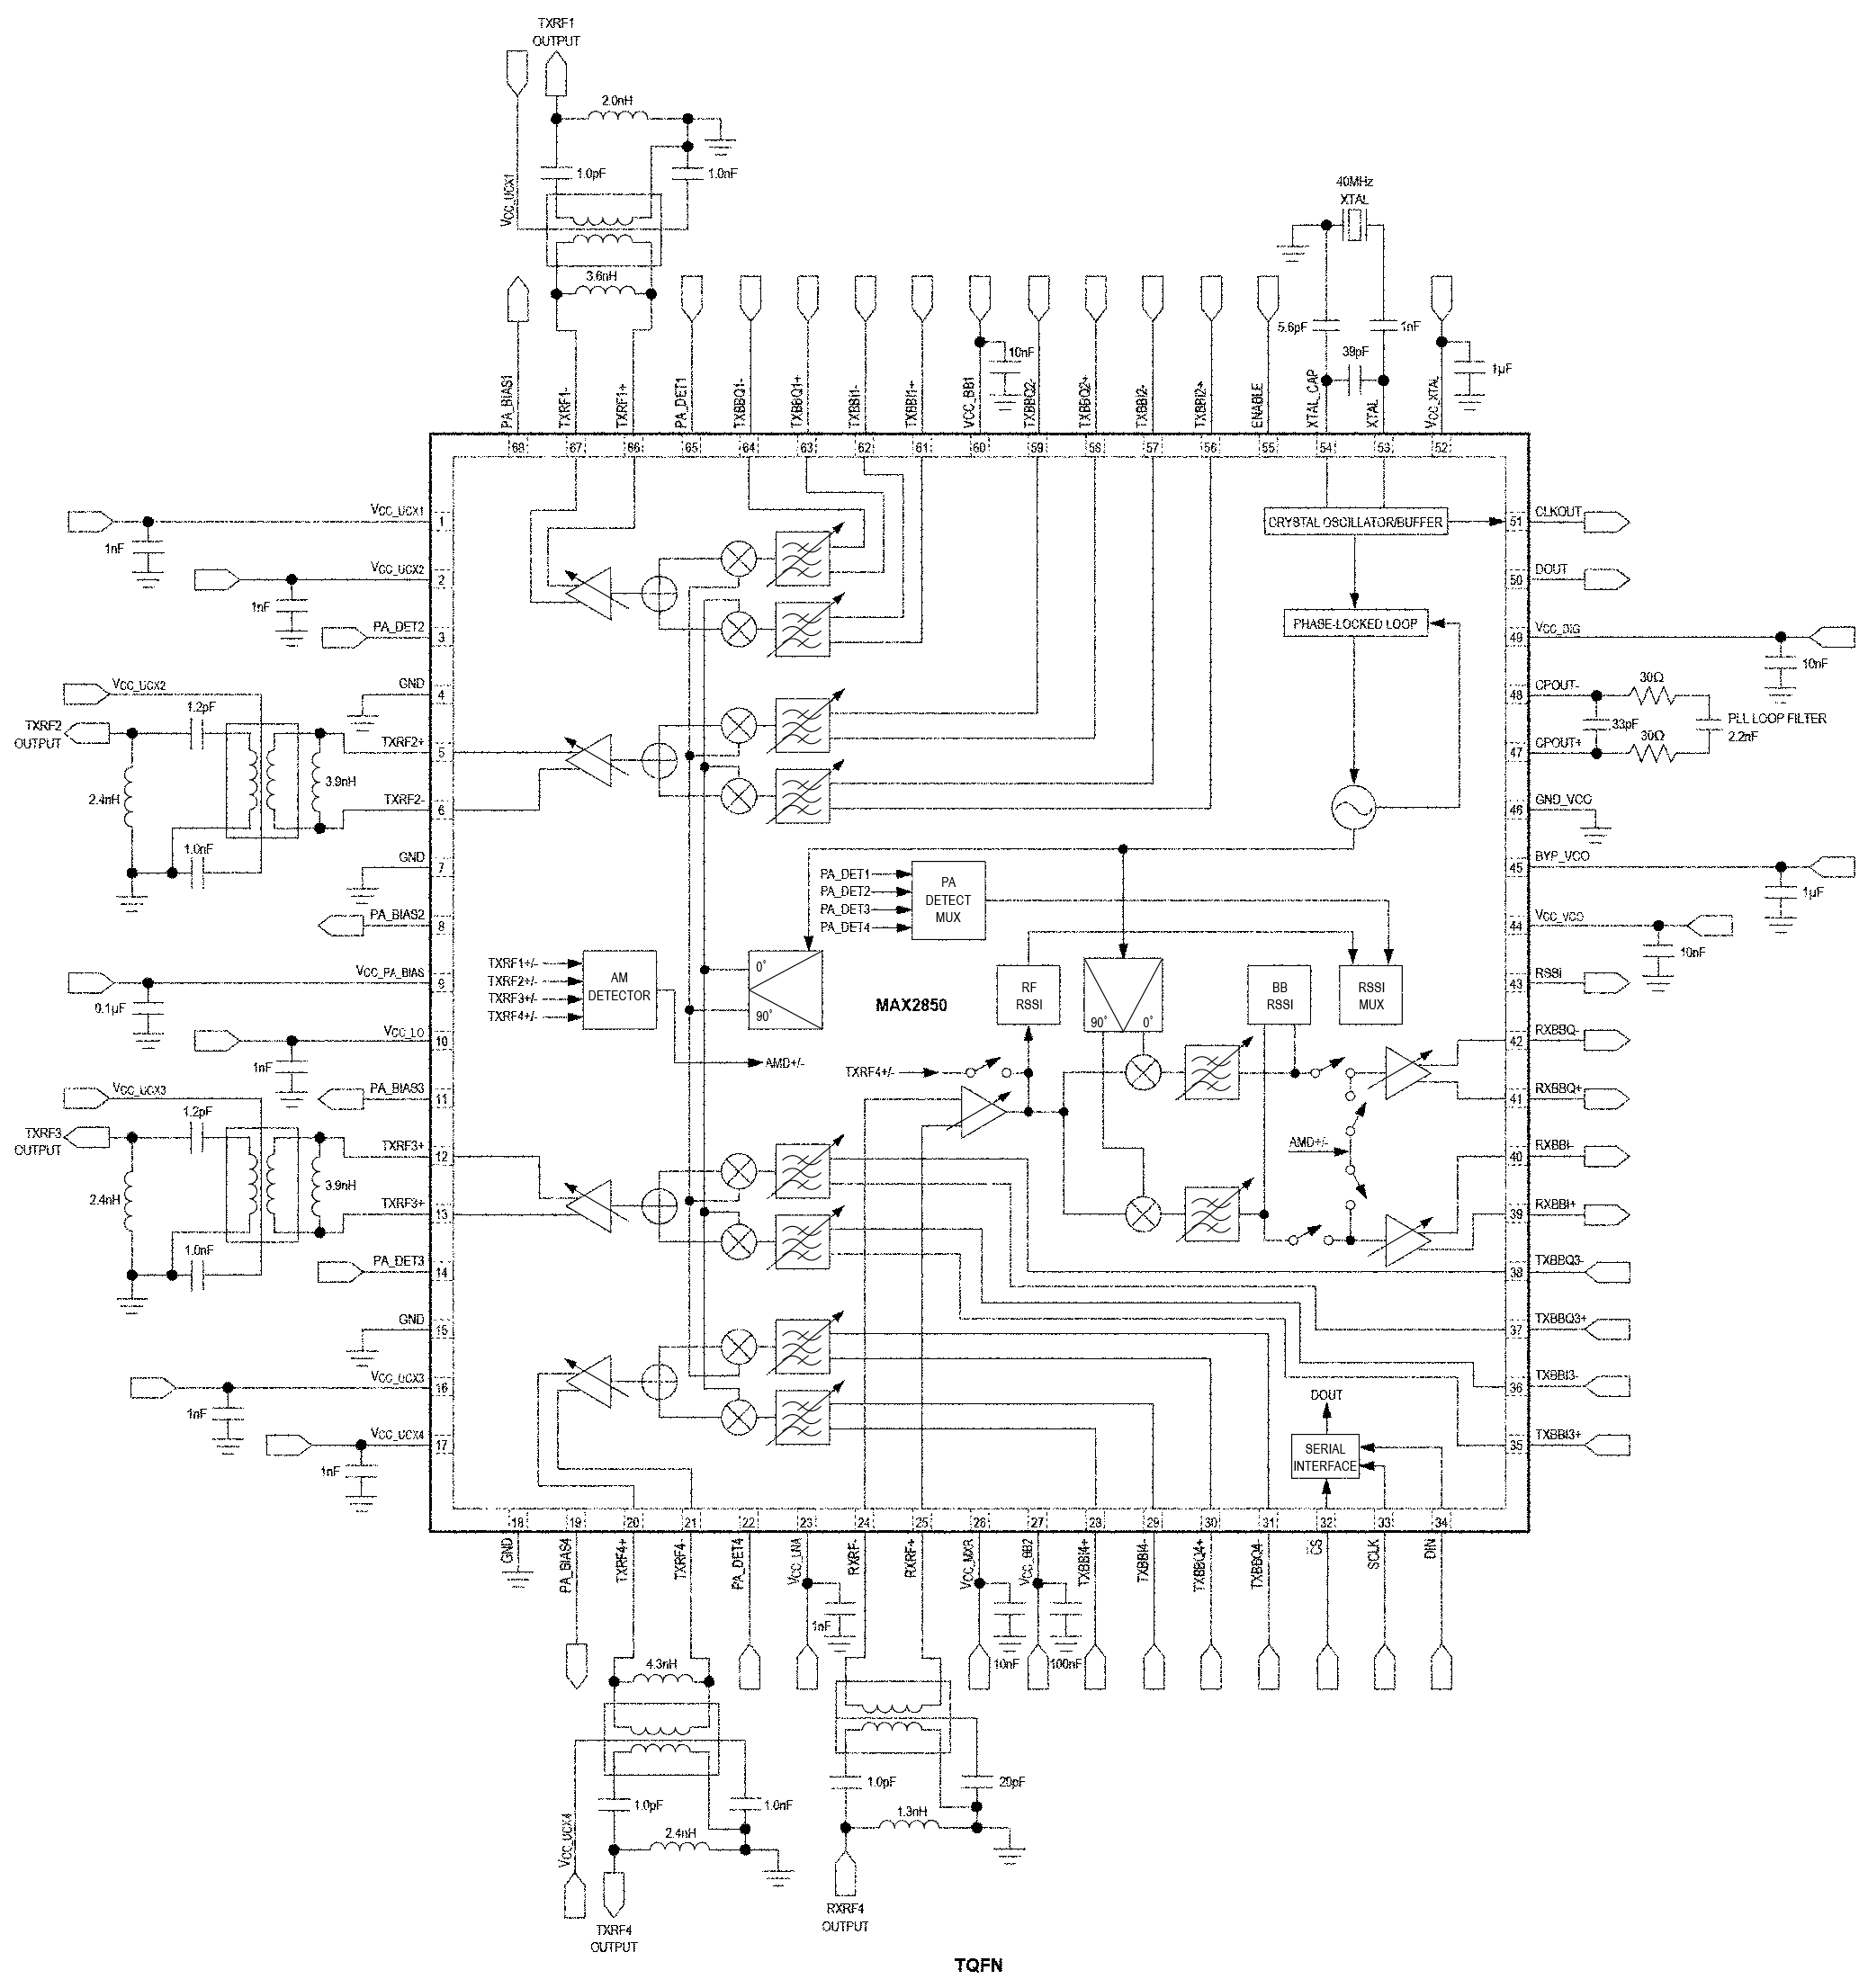
MONITOR/DISPLAY
WIRELESS / RF

